The women that assembled at the door
of the tabernacle of the congregation (Exo 38:8, 1Sa 2:22)

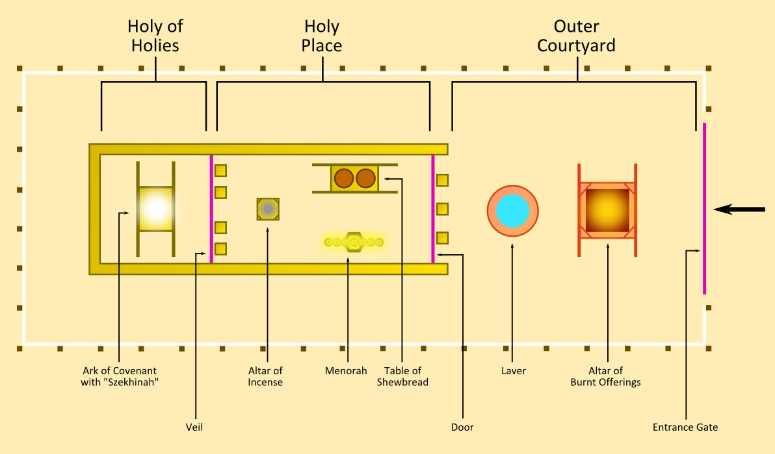

First, we establish where these woman were assembled.

- The “entrance gate” is called the “gate of the court”
  - Exo 27:16, 38:18, Num 4:26
- The “door of the tabernacle” is the door of the sanctuary (Exo 38:27)
  - Exo 29:4,11,32,42, 38:8,30, 40:12, Lev 1:3,5 3:2, 4:4, Num 3:25, 6:13, Jos 19:51, 1Ch 9:21, et. al.

Exodus 38:8
And he made the laver of brass, and the foot of it of brass, of the lookingglasses of the women assembling, which assembled at the door of the tabernacle of the congregation.

Second, we check the law and see who was permitted to be there and when (not all refs. listed).

Numbers 18:1-7
¹ And the LORD said unto Aaron, Thou and thy sons and thy father's house with thee shall bear the iniquity of the sanctuary: and thou and thy sons with thee shall bear the iniquity of your priesthood.
² And thy brethren also of the tribe of Levi, the tribe of thy father, bring thou with thee, that they may be joined unto thee, and minister unto thee: but thou and thy sons with thee shall minister before the tabernacle of witness.
³ And they shall keep thy charge, and the charge of all the tabernacle: only they shall not come nigh the vessels of the sanctuary and the altar, that neither they, nor ye also, die.
⁴ And they shall be joined unto thee, and keep the charge of the tabernacle of the congregation, for all the service of the tabernacle: and a stranger shall not come nigh unto you.
⁵ And ye shall keep the charge of the sanctuary, and the charge of the altar: that there be no wrath any more upon the children of Israel.
⁶ And I, behold, I have taken your brethren the Levites from among the children of Israel: to you they are given as a gift for the LORD, to do the service of the tabernacle of the congregation.
⁷ Therefore thou and thy sons with thee shall keep your priest's office for every thing of the altar, and within the vail; and ye shall serve: I have given your priest's office unto you as a service of gift: and the stranger that cometh nigh shall be put to death.
- Specific duties are divided among the Levites and the priests (Aaron and his sons)
  - The Levites are to serve the priests.
  - The Levites are not permitted to come near any of the vessels of the sanctuary or the altar.
- “a stranger” was not permitted to come near to the Levites or the priests (v4). In this context “a stranger” is three-fold based on the division of duties.
Group | Permitted Access/Role | Status as "Stranger" (only in this context)
Aaron & Sons | The altar, inside the vail, and the sanctuary | Never a stranger in the Tabernacle
The Levites | Serving the priests; keeping the charge of the tabernacle | A "stranger" to the Altar/Sanctuary (v3)
All other Israel | The outer court (to bring sacrifices) | A "stranger" to the Levite/Priestly service (v4)

Only under specific circumstances were “strangers” (Lev 22:18; not priests nor Levites) permitted to be “at the door of the tabernacle of the congregation before the LORD”:

Verses | Purpose
Lev 1:1-3 | Burnt offering
Lev 3:1,2 | Peace offering
Lev 12:6,7 | Burnt offering & sin offering  (a woman after giving birth and her purifying is fulfilled)
Lev 14:11 | For a leper in the day of his cleansing
Lev 15:13,14 | He that hath an issue is cleansed of his issue
Lev 17:1-5, 8-9 | Peace offerings, burnt offering or sacrifice
Lev 19:20,21 | Trespass offering
Num 6:9-11 | Sin offering, burnt offering
Num 6:18 | Nazarite shaving the head of his separation
Num 10:3 | Calling of the assembly (with trumpets of silver)

Those who had a running issue, leprosy, or had been defiled by the dead couldn’t even stay in the camp so they were necessarily excluded from the court area (Num 5:2,3, Lev 13:46). The tabernacle (as a whole; including the court) was not a place where anyone could come and go as they pleased (Num 1:51).

Under the assumption that these woman were obeying the law there is only one allowance for who they were and that is that they had to be Levites. And, since the Levites were given to the priests to minister to them those woman could only perform duties not restricted only to men.

Duties given only to male Levites:
- All of the “work in the tabernacle of the congregation” was restricted to male Levites (Numbers 3:15, 4:2,3). The word work here covers a broad range of physical activities and is the exact same Hebrew word used in Exodus 20:9 “Six days shalt thou labour, and do all thy work:”
  - The word “in” is extremely important in Num 4:3 because it implicitly allows the females to do “work” outside of the tabernacle of the congregation. This includes but is not limited to assisting the priests with their duties, preparing oil, wood, unleavened bread, incense, and of course singing and praising God, studying the word of God, fasting, and prayer.
- The carrying of the various parts of the tabernacle when it was transported (Num 4:2,22,29).
- “keep the charge of the tabernacle of the tabernacle of testimony” (Num 1:53). Lit. “to hedge about”, “to guard”, “to protect”, or “to attend to”. The broader context infers males only.
  - Refer to https://cheerful-wmcdannell.wordpress.com/2024/09/12/tribes-around-the-tabernacle/ for a diagram of where each tribe was to camp around the tabernacle (it was surrounded by the camps of the families of Levi on the North (Mararites), West (Gershonites), and South (Kohathites) with Moses, Aaron and his sons camped on the East).

Now that we’ve identified their physical duties, let’s switch gears and identify their spiritual duties.

English | 1524 Bomberg MT | Precise Grammatical Function
of the women assembling^{H6633}, | הַצֹּבְאֹת | הַצֹּבְאֹת Ha-tzov'ot: The "Host" (Noun form; feminine plural active participle). This root almost exclusively refers to a “host”, “army”, or “ranked company”.  Grammatically, almost identical to the Hebrew noun form which is “hosts” in the phrase “The LORD of hosts” (הַצֹּבְאֹת vs צְבָאוֹת). This was not a casual gathering but a conscripted unit with a defined structure.  H6633 is translated elsewhere as “perform”, “wait”, “warred”, “mustered”, “fight”, and “fought”.
which assembled^{H6633} | אֲשֶׁר צָבְאוּ | Asher tzava’u: Who "marshaled" (Verb form; Qal perfect 3rd person plural; lit. “they marshaled” or “they served a term of military-like duty”).

The highlighted portion denotes a “double use” where two different forms of the same root are used. This is a Hebrew idiomatic expression called “reduplication” and this kind is called a “polyptoton”. Another, more easily recognizable idiomatic Hebrew expression (superlative degree) is in Exodus 26:33 “most holy” where the noun is repeated “קֹדֶשׁ הַקֳּדָשִׁים" (Qodesh Ha-qodashim or “holy of holies”). Even more easier to recognize is when that same idiomatic structure was translated directly into the English (eg. King of kings, Song of songs). Why is that idiomatic expression so important here? Simply put, it specifically identifies these woman not just as “workers” but instead as “office-holders”. In order to hold an office one has to be appointed or in this context: ordained [by God].

Equally as important is the specific forms of roots used to form the English “assembling” and “assembled”. These are not the same as the typical roots we see for other types of Levite service.

Hebrew Root | Primary Meaning | Usage in the Levitical Law | Significance for the Women (Exo 38:8)
עָבַד (Abad) | Physical Labor / Burden | Numbers 3:7-8: To do the service (abodah) of the tabernacle; specifically the "charge" of the instruments and the "burden" of moving the structure. | If used, it would imply the women were merely manual laborers or cleaners of the courtyard.
שָׁרַת (Sharath) | Sacred Ministry / Liturgy | Numbers 3:6: Bring the tribe of Levi near... that they may minister (sharath) unto Aaron. Also Exodus 28:43: To minister in the holy place. | If used, it would imply the women had a ritualistic/altar-based function, which was restricted to Aaron and his sons (Num 18:7).
צָבָא (Tsaba) | Military Host / Warfare | Numbers 4:3: All that enter into the host (tsaba), to do the work in the tabernacle. | Exodus 38:8: Identifies them as a marshaled company or guard detail stationed at the threshold.

Putting all the details we have gathered together we can now understand both the primary (spiritual) and the secondary (physical) duties of the woman that were gathered at the door of the tabernacle of the congregation. They were “stationed” there not just as servants to the priests but primarily as “guards” for “spiritual warfare”.

In light of 1Sa 2:22 (along with Jer 7:12-14, Jer 26:6; which tells us that the same thing that happened to the house of God in Jerusalem (2Ki 25:8-10, 2Ch 36:19, Jer 52:12-14) happened at Shiloh) together with the archeological record at Shiloh (which tells us that the time period that the destruction and fire at Shiloh occurred was the same as Eli and his sons), we learn that not long after the judges, the priests, and these “guardians” at the tabernacle had compromised themselves, Shiloh was destroyed and burned (the archeological record also suggests that it was accomplished by the Philistines).

Thus concludes my report on the “woman at the door of the tabernacle of the congregation”. I hope that your expectations were exceeded and that you enjoyed this study as much or more than I did.

Extra notes
History and etymology of brass (and bronze)
Exodus 38:8
And he made the laver of brass, and the foot of it of brass, of the lookingglasses of the women assembling, which assembled at the door of the tabernacle of the congregation.
- The looking glasses were most likely borrowed from the Egyptians (Exo 12:36) and so we can look to archeology of the Egyptians of that time period to determine what type of personal mirrors the woman donated.
- From the 16th to the 13th centuries BC mirrors were not made of glass with silver backing as they are today. Instead, they were highly polished metal disks made of either bronze (an alloy of copper and tin) or nearly pure copper.
  - That the mirrors were most likely bronze can easily be reconciled with the early modern English term “brass” because it was a term used for any alloy of copper.
    - When copper and tin are mixed we now call that bronze.
      - 15th to 13th century BC
    - When copper and zinc are mixed we now call that brass.
      - Calamine Brass (100BC-300AD)
      - Industrial Brass (1100-1500AD)
      - Zinc-based Brass (1738D-Present)
  - There are technical reasons why Zinc was not used in early metallurgy:
    - Zinc is a “volatile” metal that boils at 907C which is lower than the melting temperature of copper which is 1,084C.
    - Therefore, in any open furnace of the Exodus period, the zinc would boil into a gas and quickly dissipate as a white smoke (zinc oxide).
    - Purportedly, it wasn’t until the Roman era that “cementation” was mastered. That is, the practice of melting metal in a sealed crucible so the zinc vapor was forced to mix with the liquid copper.
    - Records of pure metallic zinc (necessary for modern brass) weren’t documented until 1738AD by William Champion’s patent.
  - The archeological record confirms that the early Israelites produced primarily what we would call bronze (an alloy of copper and tin)

Technical comparison of root forms codified as H6633

Reference | English | Hebrew | Morphology | Plain Meaning
Exo 38:8, 1Sa 2:22 | assembled | הַצֹּבְאוֹת | Qal Participle (Feminine Plural) | Women performing organized, systematic service.
Num 4:23 | perform | לִצְבֹּא | Qal Infinitive Construct | To enter into the "army" or "host" of the ministry.
Num 8:24 | wait | לִצְבֹּא | Qal Infinitive Construct | To report for duty; to take one's place in the rank.
Num 31:7,42 | warred | וַיִּצְבְּאוּ | Qal Imperfect (3rd person masc. plural) | They executed a military campaign or massed for battle.
2Ki 25:19, Jer 52:25 | mustered | הַמַּצְבִּא | Hiphil Participle (Masculine Singular) | The one causing the army to assemble/enroll.
Isa 29:7,8 | fight | הַצֹּבְאִים | Qal Participle (Masculine Plural) | Those massing or crowding together to wage war.
Isa 31:4 | fight | לִצְבֹּא | Qal Infinitive Construct | To come down with force as an organized host.
Zec 14:12 | fought | צָבְאוּ | Qal Perfect (3rd person plural) | They have massed or gathered for the purpose of battle.

